**Sustainable supply performance dashboards using power BI**

Data Analysis: keep facts, insights via dashboards.

**How we build dashboards?**

* Using BI tools
* Here BI stands for (business intelligence)

**ETL(Extract transform load)**

* Extract- pull data from data source

Here data sources are – excel, csv, text, database file etc.

Excel: records are stored by rows & columns, row by row.

CSV: records are stored by separating commas.

* Transform-data processing , data cleaning.
* LOAD- for analysis.

**When we use load and transform in power bi?**

**Load**  - when your data is cleaned.

**Transform** -when you want to process the data.

**POWER BI**

Step1: In the welcome page of the power bi, we need to click on the blank report to create a new project.

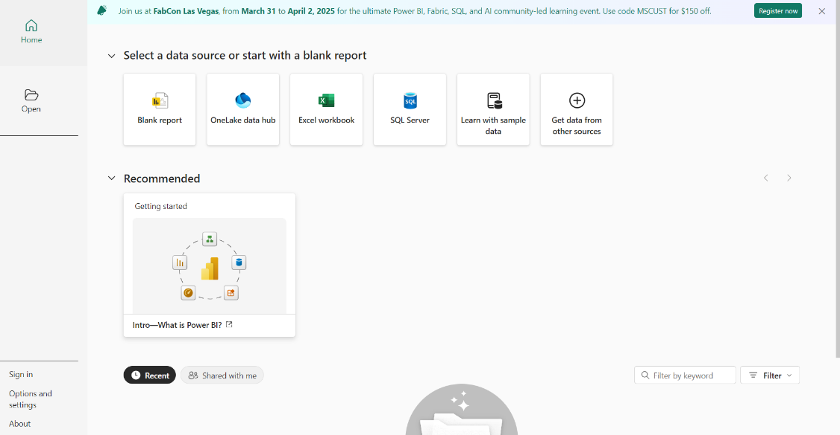

Step2: After clicking the blank report. We see power bi text of window.

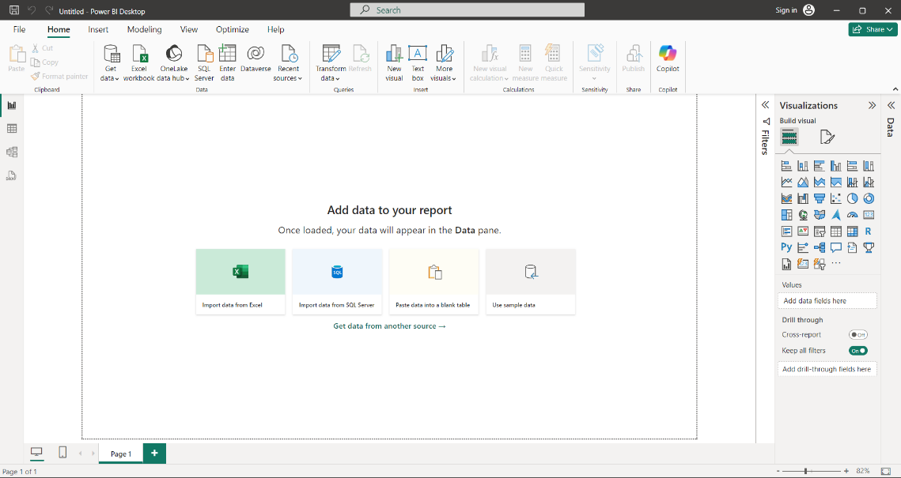

Above the white window (space) is called as canvas. Here we draw charts

Step 4: How we can extract the data

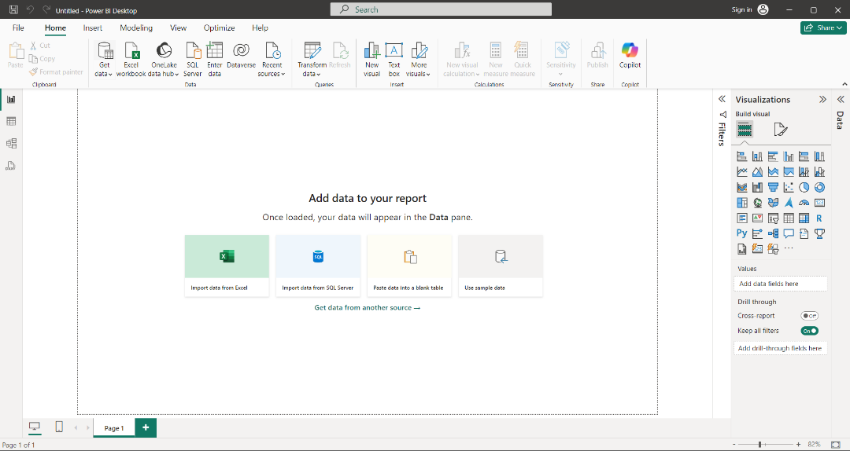

if we click on the get data. It connect to data from multiple sources like excel and csv etc.

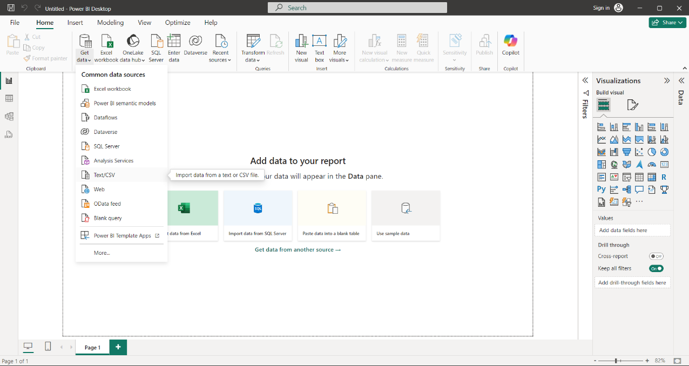

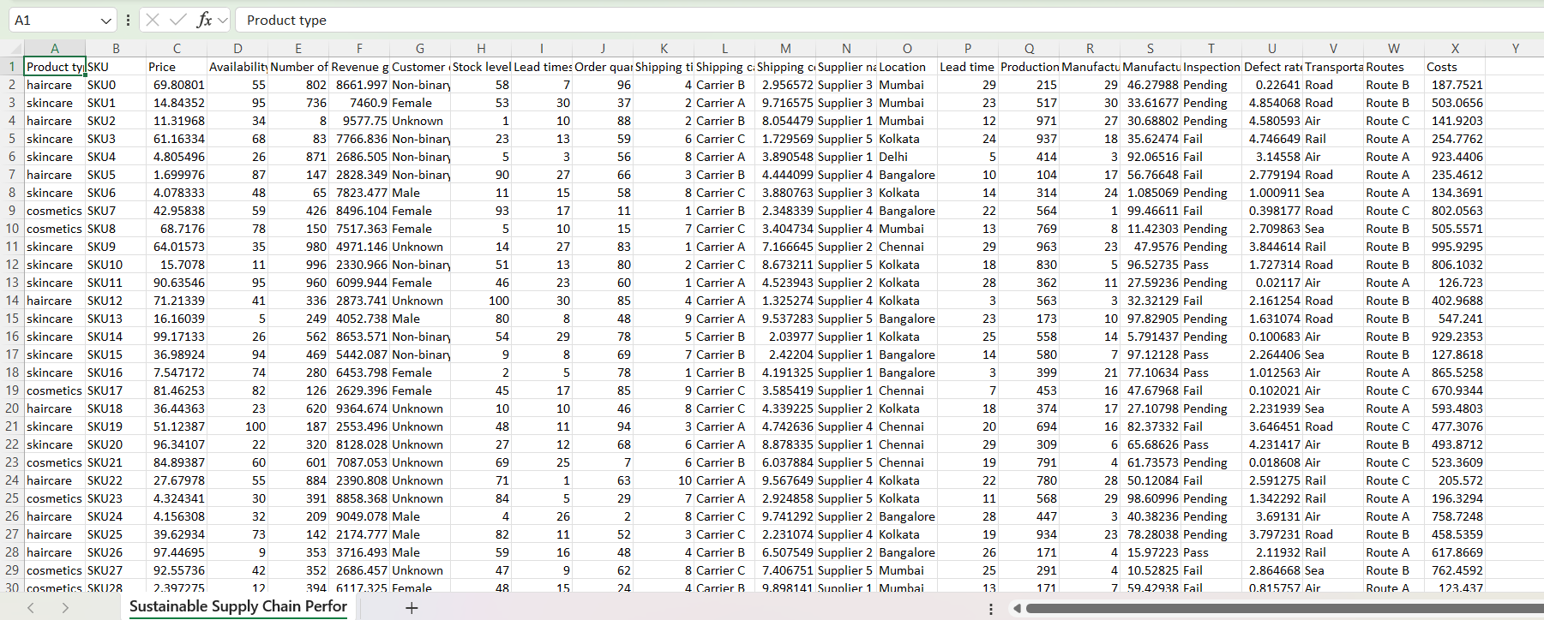

So this file is imported by clicking on the text/csv

Step5:In the left side we have

**Report view**-used when we want to perform visualizations.

**Table view**-to see the data which we imported the file.

**Model view**- use on 2 to 3 tables simultaneously. So that we create relationship among them.

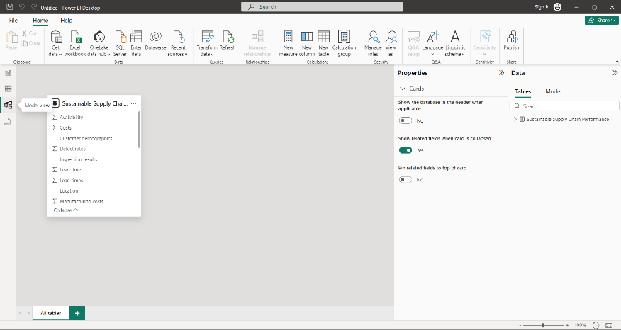

**Can we transform the data after we loaded.**

Yes. By clicking on the transform data. That window we called as “power query editor”.

Step 6: Go to the view icon and click the column quality checkbox.It rectifies errors.

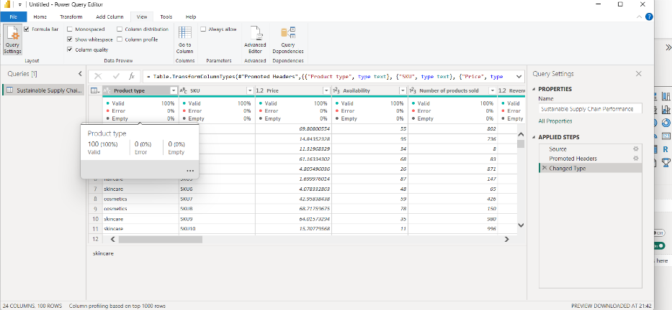

So here we see 0% empty.

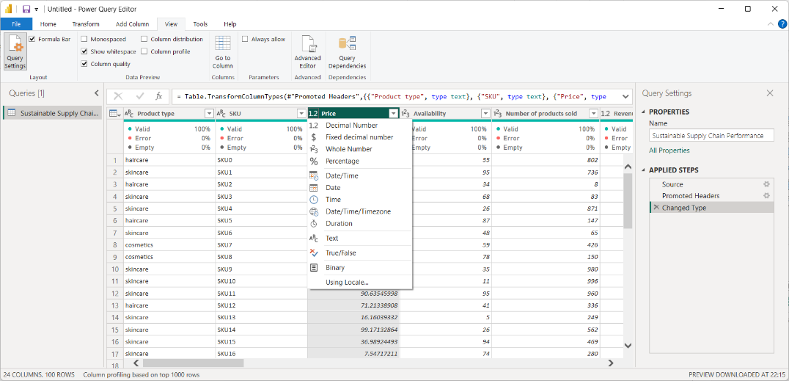

Above we see datatypes of particular column.

Step7: In left side we have “queries”-which is that we imported file.right click on that and tap duplicate. Again click on the 2nd file rename according to the below table names.

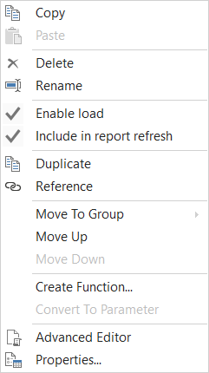

Step8:

**Inventory Table:**

1. Product type

2. SKU

3. Availability

4. Number of products sold

5. Customer demographics

6. Stock levels

7. Lead times

8. Order quantities

9. Lead time

10. Revenue generated

**Manufacturing table**

1. Product type

2. SKU

3. Production volumes

4. Manufacturing lead time

5. Manufacturing costs

6. Inspection results

7. ⁠ defect rates

**Supplier Table**

1. Supplier name

2. Location

3. Lead time

4. transportation modes

5. Routes

**Supply chain table**

1. Product type

2. SKU

3. Price

4. Availability

5. Number of products sold

6. Revenue generated

7. Customer demographics

8. Stock levels

9. Lead times

10. Order quantities

11. Shipping times

12. Shipping carriers

13. Shipping costs

14. Supplier name

15. Location

16. Lead time

17. Transportation modes

18. Routes

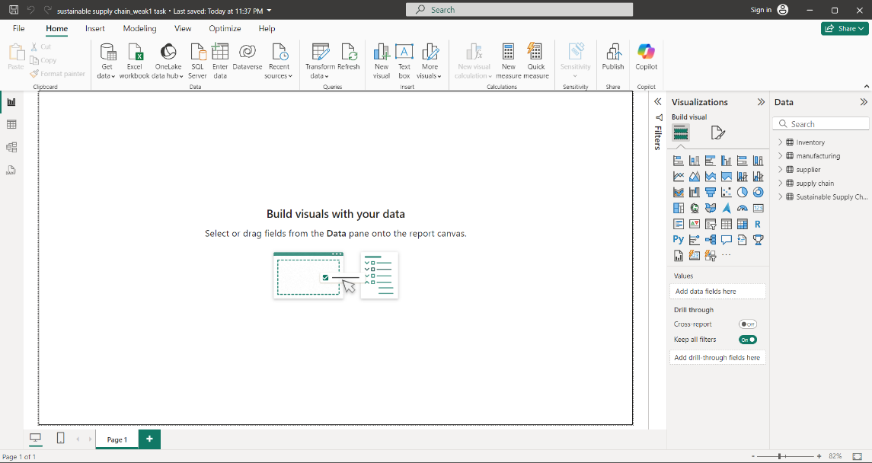

After doing all the tables we will see in the right side “Data”

Step 9: Go to home. And click close and apply.

Step 10: Go the file and save as project name_weak1task.